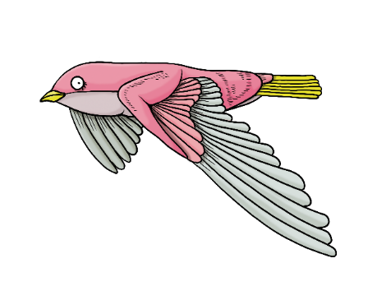

Hello __________,

I hope you enjoyed the Tiny Forest ________ event as much as we did!

First, let me take this opportunity to thank you wholeheartedly for all of your effort today. It was amazing to see you and the whole community coming together to ________. Because of your collective efforts, ________ Tiny Forest is already working it’s magic: connecting people with nature, helping to mitigate the impacts of climate change, and providing nature-rich habitat to support urban wildlife! You can read more about Tiny Forest on [our website](https://tinyforest.earthwatch.org.uk/).

If you want to be more involved with _________ Tiny Forest, e.g. helping with it’s maintenance and nurture, being a citizen scientist and collect valuable scientific data from the Tiny Forest, or help the community celebrate this amazing resource, you can sign-up to be a Tree Keeper! We know that volunteers have limited amounts of time that they can devote to their Tiny Forests, but you can adapt your Tree Keeper experience to suit the time you have available, and also your own interests. To sign-up as a Tree Keeper write to us at [tinyforest@earthwatch.org.uk](mailto:tinyforest@earthwatch.org.uk).

To hear about upcoming events such as planting days, community science days, and webinars, please follow [Earthwatch on Eventbrite.](https://www.eventbrite.co.uk/o/earthwatch-europe-16912398845) The event you attended today was run by _________ student group in partnership with Earthwatch. You can find out more about events run by this student group through ___________. We loved your energy and enthusiasm, and would be delighted to see you at future events!

If you would like to support Tiny Forest with a donation, you can visit our [donation page](https://tinyforest.earthwatch.org.uk/donate). And to have a peek at all the other amazing work being done by Earthwatch, you can check [our website](https://earthwatch.org.uk/), and by ________ student group, you can learn more ________.

Finally, if you have any questions about Tiny Forests, please feel free to give us a shout at [tinyforest@earthwatch.org.uk](mailto:tinyforest@earthwatch.org.uk) .

It was wonderful to have you at our _________ event, and we hope to see you again soon!

Kind regards,

__________